**Stakeholders (Students, Teachers and Alumni’s) Feedback, Analysis and Action Taken Report**

**Introduction:**

The college carries the process of syllabus from various stakeholders such as alumni, faculties and students. The prime motive behind carrying out this process is to know the current scenario and opportunities in market for employability of the students.

**Objectives of the Feedback:**

1. To understand the real challenges faced by the alumni while working in the industry and practical exposure through syllabus learning.
2. To provide necessary changes for upgrading the syllabus based on their expertise and teaching enrichment while carrying out the process of teaching learning.
3. To provide necessary upgrading in content of syllabus, current trends in various areas of management and reduce the outdated portion of the syllabus from curriculum.

**Process of Feedback and Action Taken**

**-**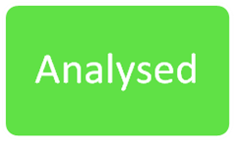

**Facts of Feedback**

Feedback is collected as shown below:

**Feedback collected from the stakeholders:**

1. **Students:** Collection of feedback from the students
2. **Teachers:** Feedback for revision of syllabus is carried out by a wide discussion among the teachers.

**3Alumni:** Alumni feedback is collected whenever alumni interact with institute about satisfaction and expectations about the syllabus.

**STUDENT FEEDBACK ANALYSIS REPORT**

On analysis of feedback supplied of UG programmes it was analysed that students have put following responses on various aspects of teaching learning evaluation scale for resolution.

1. In the answer of 1st question of student feedback questionnaire 48.2% students replied that it is Good

2. In the answer of 2nd question of student feedback questionnaire 55.5% students replied that it is good. A minor improvement is also needed to make this point excellent.

3. In the answer of 3rd question of student feedback questionnaire 47.3 % students replied that it is AGREE . We need an improvement by which we can able to make students agreed with this internal assessment process.

4. In the answer of 4th& 5th question of student feedback questionnaire 41.8% & 48.2% students replied respectively that these are excellent. There is noneed for improvement in these points.

5. In the answer of 6th question of student feedback questionnaire 50.9% students replied that it is Good. A nuance improvement is needed to make this point excellent.

6. In the answer of 7th, 8th& 9th question of student feedback questionnaire 90.0%, 88.2% & 88.2% students replied respectively that these are excellent. There is no need for improvement in these points.

The overall student feedback analysis report is excellent and good.

**GOVERNMENT COLLEGE SATNALI, MAHENDERGARH**

**For the Session 2023 - 2024**

**Student Feedback Analysis**

|  |  |  |  |  |  |  |
| --- | --- | --- | --- | --- | --- | --- |
| **Sr. No. of Question** | **No. of Feedback Collected** | **Excellent/Strongly Agree/Yes** | **Good/Agree/Very Good** | **Fair/Average/Neutral** | **Poor/disagree/No** | **Overall Analysis** |
| **1** | **110** | **41.8%** | **48.02%** | **4.5%** | **5.5%** | **good** |
| **2** | **110** | **55.5%** | **31.8%** | **9.1%** | **3.6%** | **excellent** |
| **3** | **110** | **28.2%** | **47.3%** | **18.2%** | **6.4%** | **agree** |
| **4** | **110** | **41.8%** | **35.5%** | **18.2%** | **4.5%** | **excellent** |
| **5** | **110** | **48.2%** | **37.3%** | **10%** | **4.5%** | **excellent** |
| **6** | **110** | **41.8 %** | **50.9%** | **5.5%** | **1.8%** | **good** |
| **7** | **110** | **90.0%** | **-** | **-** | **10.0%** | **excellent** |
| **8** | **110** | **88.2%** | **-** | **-** | **11.8%** | **excellent** |
| **9** | **110** | **88.2%** | **-** | **-** | **11.8%** | **excellent** |

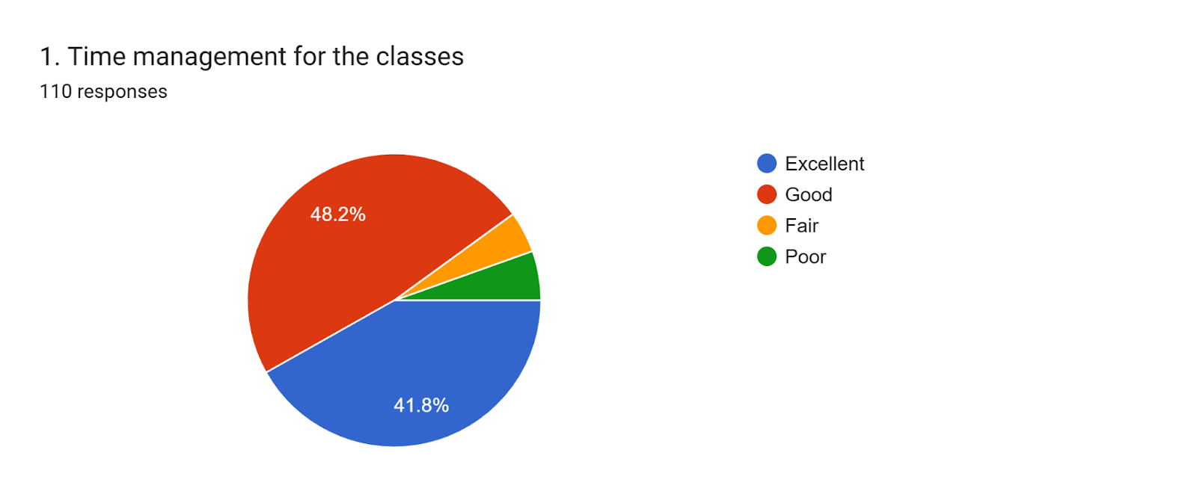

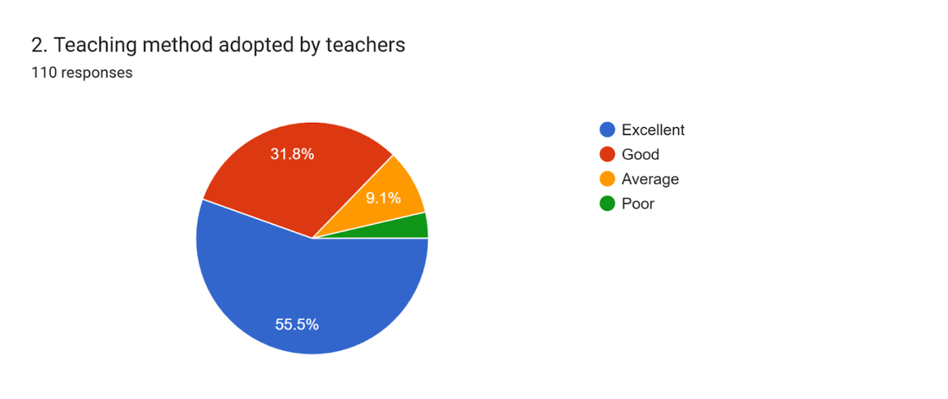

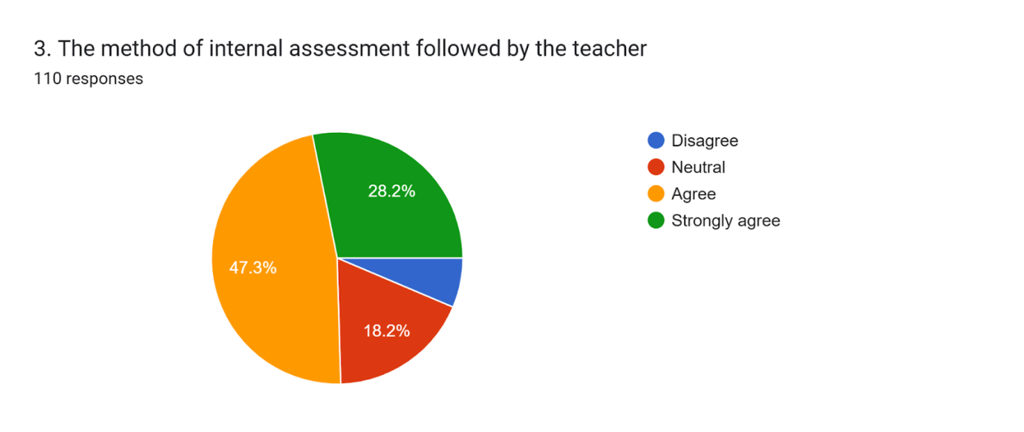

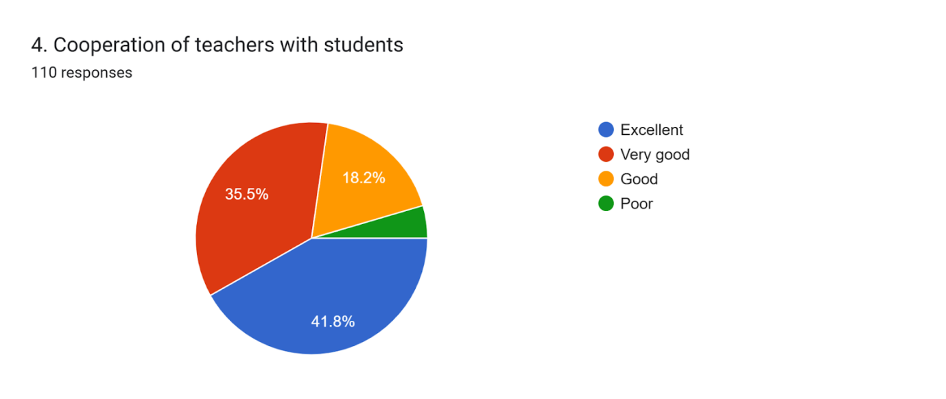

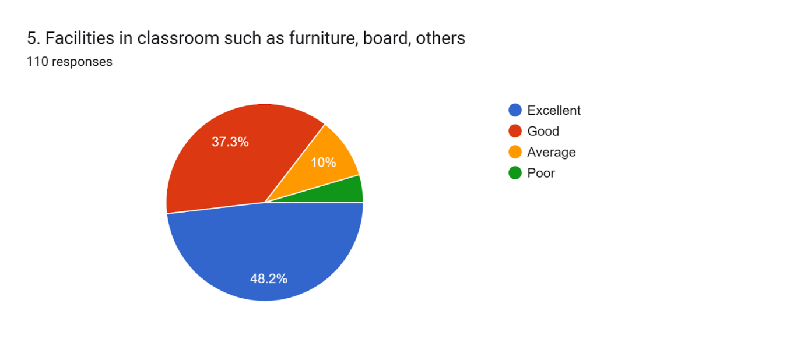

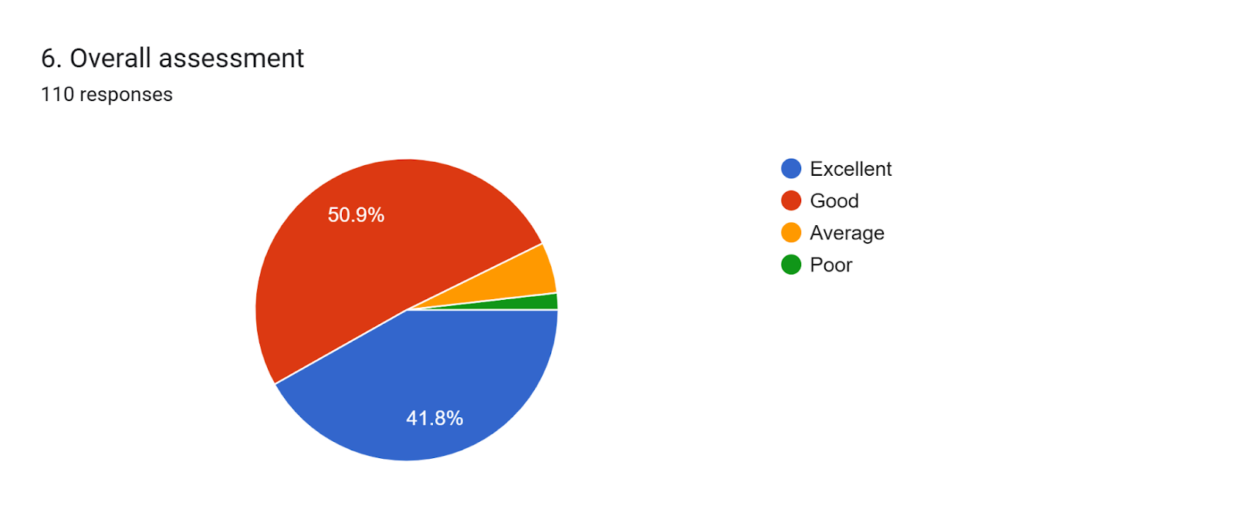

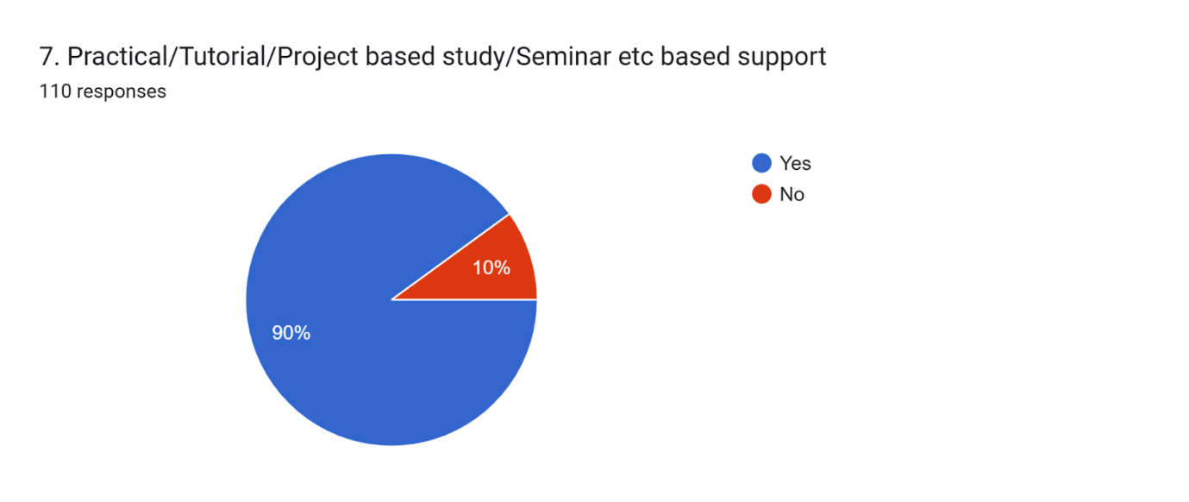

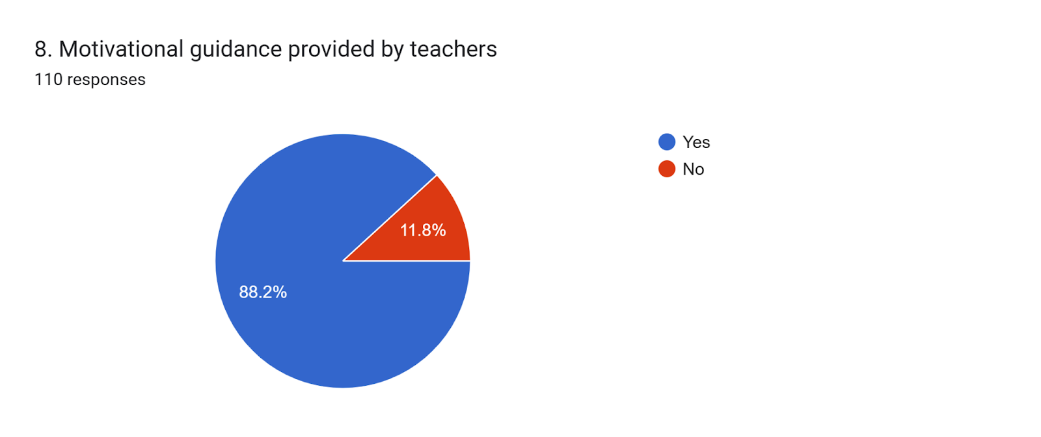

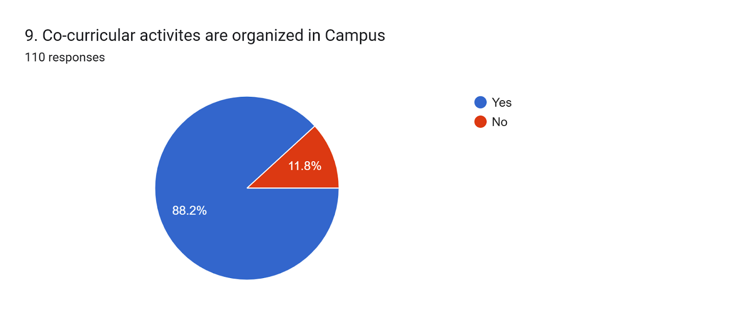

**ALUMNI FEEDBACK ANALYSIS REPORT**

On analysis of feedback received at UG level programmes which is done through questionnaire method in which total 33 alumni respondents were participated. In the answer of first question of our alumni feedback 97.0% alumni respondent answered in Yes and 3.0% answered in No. On the basis of aforementioned information, the overall result is very good. In question number second 69.7% alumni respondent answered that it is very good and 30.3% answered that it is good and satisfactory, so we can say that overall result is very good.

In question number 3rd 72.7% respondent answered that it is cooperative, 27.3% said that it is motivational and 0.0% answered that it is unsatisfactory. The overall result is cooperative. In the answer of 4th question 78.8% respondents said that it is good, 22.2% answered that it is satisfactory and 0.0% replied that it is unsatisfactory. The overall result is good. In the answer of 5th question 72.7 % respondents pointed five stars, 21.2% pointed three stars, 0.0% pointed two star and 6.1% pointed that it is normal. The overall Result is five stars. Total alumni feedback analysis report is very good and cooperative.

**GOVERNMENT COLLEGE SATNALI, MAHENDERGARH**

**For the Session 2023-24**

**Alumni Feedback Analysis**

|  |  |  |  |  |  |  |
| --- | --- | --- | --- | --- | --- | --- |
| **Sr. No. of Question** | **No. of Feedback Collected** | **Yes /very good /five star** | **Good/cooperative /three star** | **Satisfaction / motivational /two star** | **Unsatisfaction / no / normal** | **Overall Analysis** |
| **1** | **33** | **97.%** | **-** | **-** | **3.0%** | **yes** |
| **2** | **33** | **69.7%** | **9.1%** | **21.2%** | **0%** | **Very good** |
| **3** | **33** | **-** | **72.7%** | **27.3%** | **0.0%** | **cooperative** |
| **4** | **33** | **-** | **78.8%** | **22.2%** | **0.0%** | **good** |
| **5** | **33** | **72.7%** | **21.2%** | **0.0%** | **6.1%** | **Five stars** |

Forms response chart. Question title: Q.1  क्या आपके समग्र व्यक्तित्व विकास के लिए कॉलेज द्वारा  प्रेरणा दी  गई.. Number of responses: 33 responses.

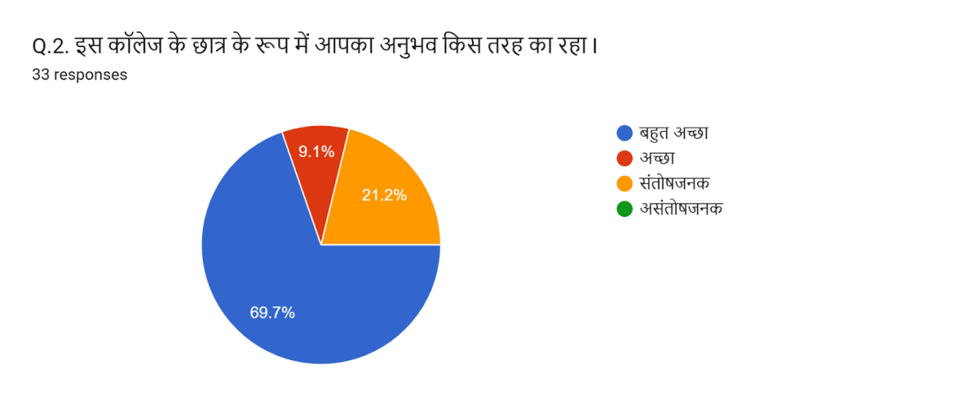

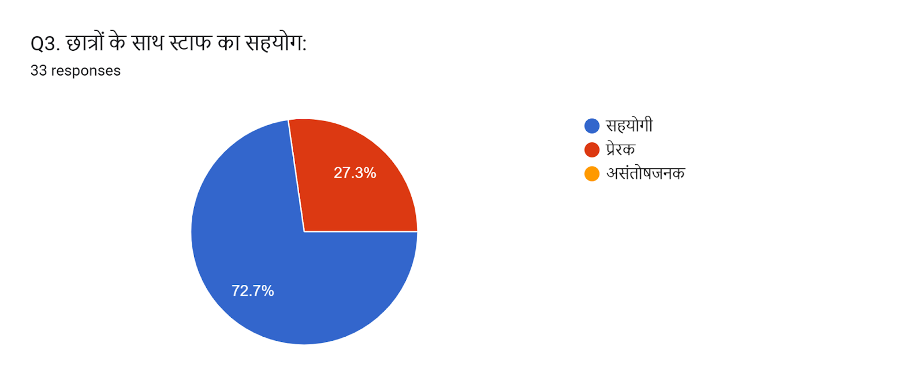

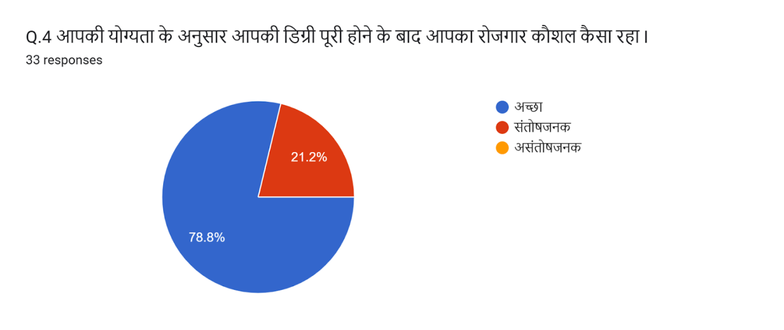

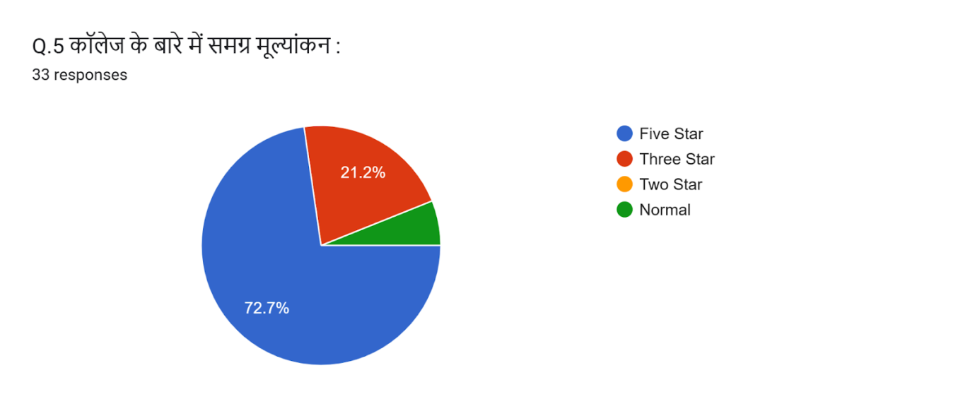

Number of Respondent Alumni with respect to 2023-24 Year of Passout

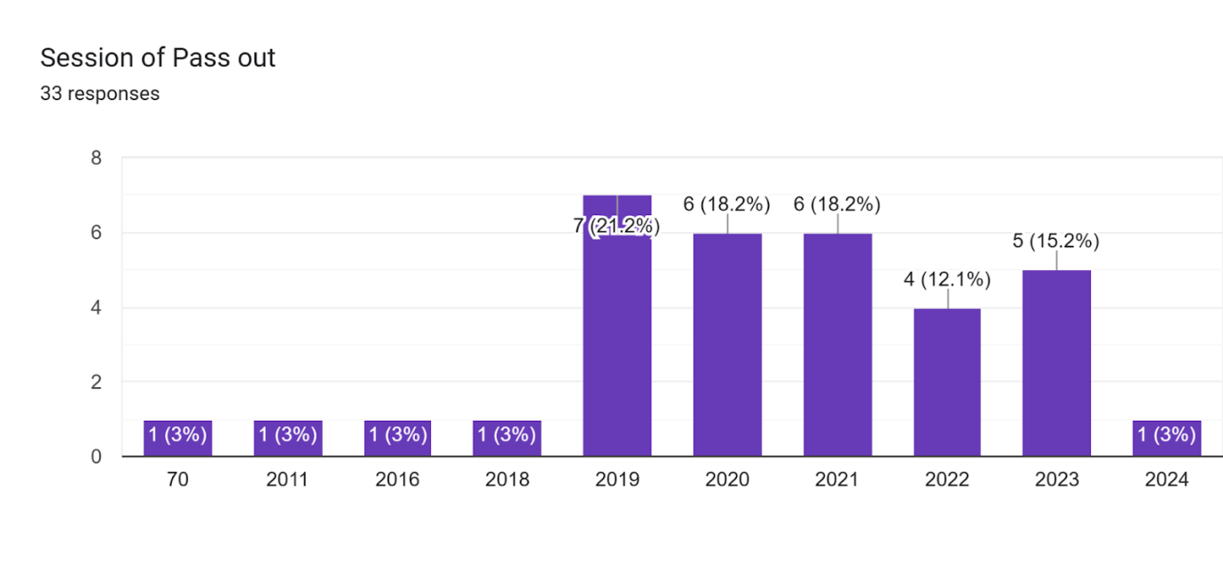

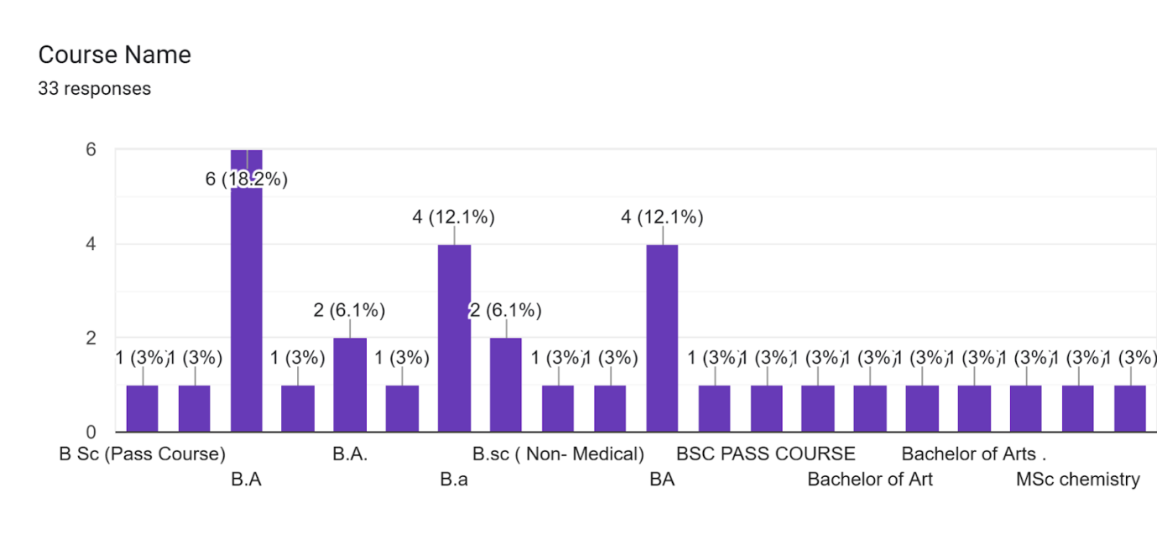

**GOVERNMENT COLLEGE SATNALI, MAHENDERGARH**

**For the Session 2023-24**

**Faculty Feedback Analysis**

**TEACHER FEEDBACK REPORT FOR REVIEW OF SYLLABUS**

On analysis of feedback supplied by teachers in the form of questionnaire based on review of syllabus, the following points have been received;

Que.1; 32.0%Teachers are Excellent, 68.0% good and over all analysis is good.

Que.2; 40%Teachers are Excellent, 28.0% good and over all analysis is Excellent.

Que.3; 100%Teachers are Strongly agree ,and over all analysis is Agree.

Que.4; 32.0%Teachers are Excellent, 60.0% good and over all analysis is good.

Que.5; 44.0%Teachers are Excellent, 48.0% good and over all analysis is good.

Que.6; 52.0%Teachers are Excellent, 36.0% good and over all analysis is good.

**Suggestion-**

1. When the syllabus is being revised. The Merchant of Venice is read in 5th Sem. one more drama must be included; -

**GOVERNMENT COLLEGE SATNALI, MAHENDERGARH**

**For the Session 2022-23**

**Faculty Feedback Analysis**

|  |  |  |  |  |  |  |
| --- | --- | --- | --- | --- | --- | --- |
| **Sr. No. of Question** | **No. of Feedback Collected** | **Excellent/Strongly Agree** | **Good/Agree/sufficient** | **Fair/Average/needs improvement/motivation** | **Poor/disagree** | **Overall Analysis** |
| **1** | **25** | **32.0%** | **68.0%** | **0.0%** | **0%** | **Good** |
| **2** | **25** | **40.0%** | **28.0%** | **32.0%** | **0%** | **excellent** |
| **3** | **25** | **100%** | **-** | **-** | **0%** | **agree** |
| **4** | **25** | **32.0%** | **60.0%** | **8.0%** | **0%** | **Good** |
| **5** | **25** | **44.0%** | **48.0%** | **8.0%** | **0%** | **Good** |
| **6** | **25** | **52.0%** | **36.0%** | **8.0%** | **4.0%** | **excellent** |

